**#Write a function safe_divide(x, y) that takes two numbers as input and divides x by y. Use a try, except block to handle division by zero. If division is successful, return the result. If division fails, return None.**

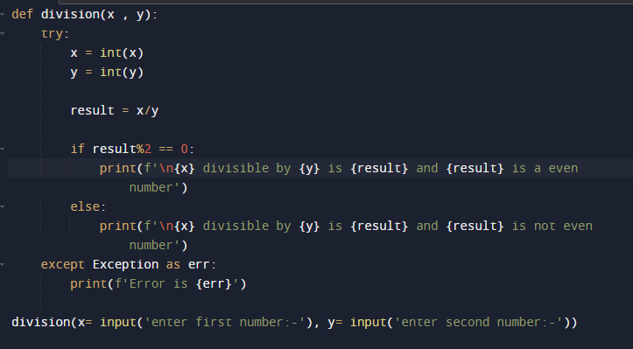

**#EXPLANATION**

1. We have written a function named division which will take two arguments x and y.
2. while calling the function we are sending x as first input number and y as second input
3. Inside the try block, we are converting both the output’s as integer.
4. Dividing the x with y.
5. And we are checking if the number is even or not.
6. If it is not an even number then we are printing in else
7. If the user is entering other than number, then we catching in try block.

**#POSITIVE CASE  
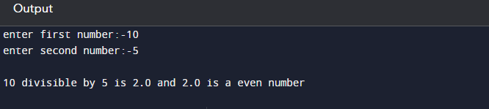**

**#NEGATIVE CASE**

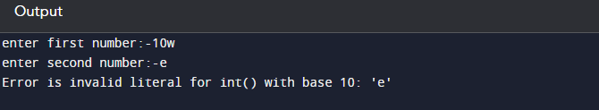

**#Write a function safe_list_index(lst, index) that takes a list lst and an index index as input. Use a try, except block to handle the IndexError exception if the index is out of range. If the index is valid, return the value at that index. If an exception occurs, print an error message and return None.**

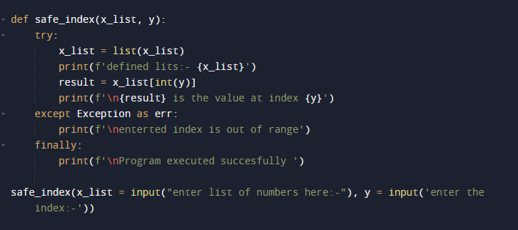

**#EXPLANATION**

1. We have defined a program safe_index which will take the user input list and user input index number.
2. Inside the function we used try and except block to catch the error and not to crash the program.
3. First input is converted as list and we are find accessing and index no in the list and storing in the result variable
4. If the index is out of range, then we are printing the same
5. Finally block will be executed by default
6. Safe_index function is called by passing the two arguments

**#Positive case**

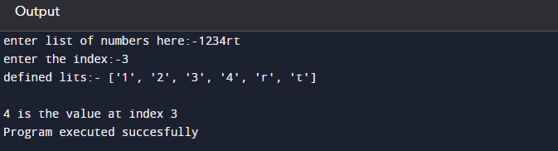

**#Negative case**

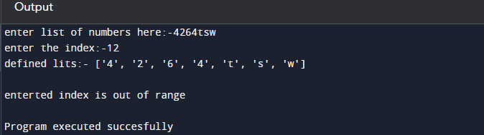

**#Write a function get_dict_value(dictionary, key) that returns the value associated with the given key in the dictionary. Handle the KeyError exception if the key does not exist in the dictionary and return None.**

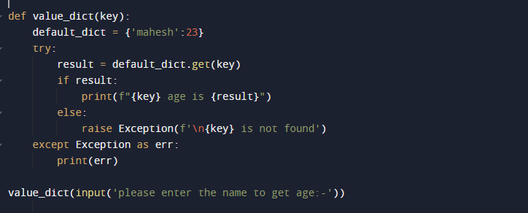

**#Positive case**

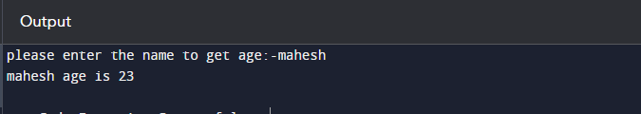

**#Negative Case**

